**PROJECT DOCUMENTATION**

Insect detection and identification

**TABLE OF CONTENTS**

|  |  |  |
| --- | --- | --- |
| S NO | Contents | Page No. |
| 1  2  3  4  5  6 | INTRODUCTION  PROBLEM STATEMENT  REQUIREMENTS  PROBLEM SOLVING APPROACH  DESIGN AND ARCHITECTURE  CONCLUSION | **3**  **3**  **3**  **4**  **5**  **6** |

1.INTRODUCTION

Worldwide economies and the world's population both depend heavily on agriculture. Pests, on the other hand, pose a serious threat to farmers and can seriously harm crops, lower yields, and contaminate food quality. Conventional pest management techniques, which frequently depend on chemical treatments and manual inspection, are not only labour and time-intensive but also dangerous for the environment and human health.

Innovative answers to these problems are provided by current technology. Using advances in machine learning and image processing, automated systems that precisely identify and detect pests on crops can be created. The goal of this project is to establish such a system, giving farmers a trustworthy instrument to keep an eye on pest activity and carry out prompt interventions.

1.1 Project Overview

The goal of this project is to develop an automated system for detecting and identifying pests on crops using image processing and machine learning. By leveraging these technologies, the system aims to assist farmers in implementing effective pest management strategies, thus reducing crop losses and enhancing productivity.

1.2 Purpose

The primary purpose of the pest detection and identification project is to develop an automated system that can accurately identify and detect pests on crops. This system aims to assist farmers in monitoring pest activity and implementing timely and effective pest management strategies, ultimately improving crop health and yield.

2.PROBLEM STATEMENT

Create a model by training the dataset to detect and identify the bug on the crop.

3.REQUIREMENTS

Hardware requirements

• Processor: Intel Core i7 or AMD Ryzen 7

• RAM: 16.0 GB

Software and Libraries

• Python: The primary programming language for this project due to its rich ecosystem of libraries and ease of use.

• OpenCV: An open-source library for computer vision tasks, useful for image

preprocessing, such as resizing, filtering, and augmenting images.

• TensorFlow/Keras: Deep learning frameworks for building, training, and deploying neural networks. TensorFlow/Keras is widely used and supported in the machine learning community.

• Scikit-learn: A machine learning library that provides tools for data preprocessing, model selection, and evaluation.

•NumPy: Fundamental package for numerical computing in Python, essential for array manipulation and mathematical operations.

•Matplotlib: A plotting library for creating visualizations and graphs, useful for analysing and presenting data.

• Jupyter Notebook: An interactive development environment that allows for easy experimentation, visualization, and debugging of code

4.PROBLEM SOLVING APPROACH

Data Collection: I Gathered a diverse dataset of images containing 12 different pests - ants, bees, beetle, earwig, moth, slug, snail, wasp, weevil, Earthworm, caterpillar grasshopper from Kaggle.

Data Preprocessing: Use OpenCV for image preprocessing tasks such as resizing, normalization, and augmentation so that there will be no sizing issues. Ensure that the data is clean, balanced, and properly formatted for model training.

Building Model: Sequential model is used here to build the convolutional neural network (CNN).Implement the selected model using deep learning frameworks like TensorFlow/Keras.

Training Model: Train the model on the annotated dataset using appropriate loss functions and optimization algorithms.

Model Evaluation and Accuracy Visualization: Evaluate the trained model using metrics such as precision, recall, F1-score, and mean Average Precision. The accuracy of the trained model is plotted on a graph and confusion matrix is visualized.

Testing and Validation: Thorough testing is done to ensure the system functions as expected. Validate the accuracy and reliability of the system by comparing its results with ground truth data.

Feature Extraction and Clustering: Extract relevant features from the image. Use techniques like Scale-Invariant Feature Transform (SIFT) or Convolutional Neural Networks (CNNs) for feature extraction. Apply a clustering algorithm to group similar features together. The goal is to cluster features that likely belong to the same object.

Bounding Box Generation: For each cluster, compute the bounding box that encapsulates the clustered points. The bounding box can be derived by finding the minimum and maximum coordinates of the points in the cluster.

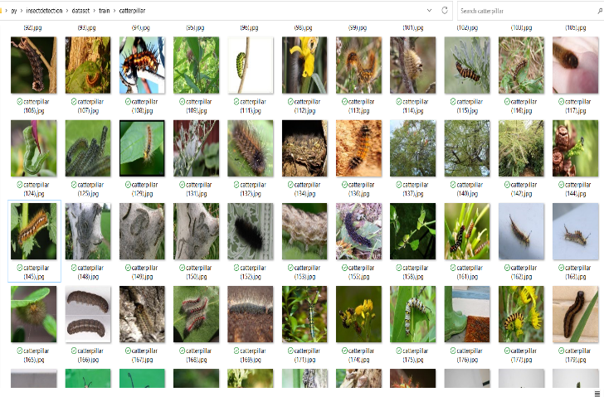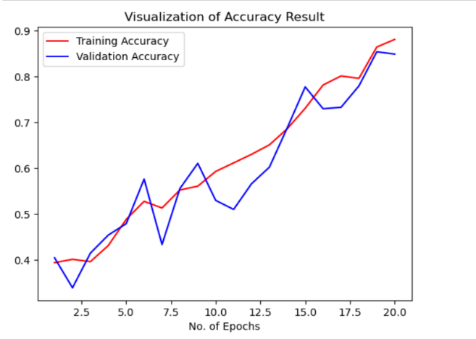

Fig: Dataset Fig: Visualization of accuracy r

DESIGN AND ARCHITECTURE

The project is designed using CNN architecture and clustering algorithm.

Convolutional neural network

Convolutional Neural Networks, abbreviated as CNN, has a complex network structure and can perform convolution operations. The convolutional neural network model is composed of input layer, convolution layer, pooling layer, full connection layer and output layer. In one model, the convolution layer and the pooling layer alternate several times, and when the neurons of the convolution layer are connected to the neurons of the pooling layer, no full connection is required. It supports huge model capacity and complex information brought about by the basic structural characteristics of CNN, which enables CNN to play an advantage in image recognition. At the same time, the successes of CNN in computer vision tasks have boosted the growing popularity of deep learning.

Convolution involves sliding a filter/kernel over the input image to extract features such as edges, textures, and patterns.

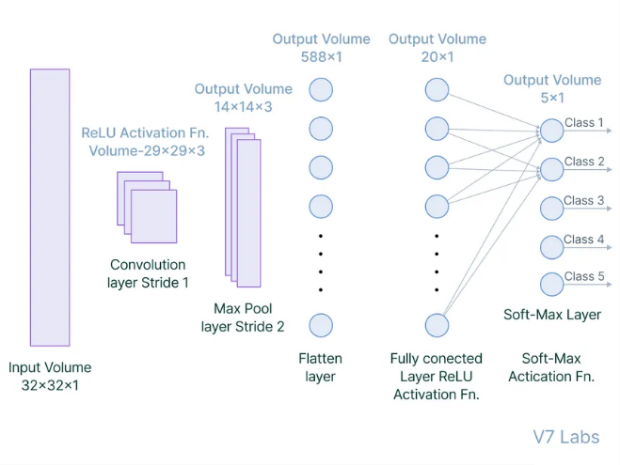

Fig: Fully connected layer in CNN

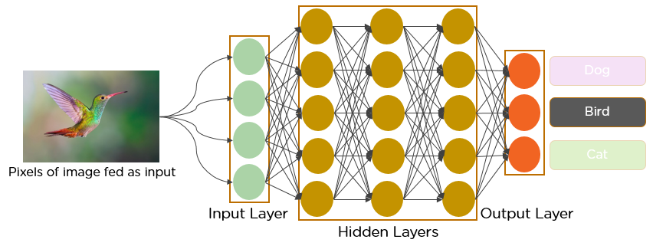

## Clustering Algorithms

Clustering algorithms are unsupervised learning techniques used to group similar data points together. The objective is to partition a dataset into clusters, where data points in the same cluster are more similar to each other than to those in other clusters. K-Means clustering algorithm is used in this project for object detection. K-Means partitions the dataset into K clusters, where each data point belongs to the cluster with the nearest mean. It is a method of vector quantization, originally from signal processing, that is popular for cluster analysis in data mining. The goal of K-means is to partition n observations into k clusters in which each observation belongs to the cluster with the nearest mean, serving as a prototype of the cluster.

CONCLUSION

The pest detection and identification project has successfully leveraged advanced computer vision and deep learning techniques to create a robust system for monitoring and managing pest infestations in agriculture. Utilizing a Convolutional Neural Network (CNN) model alongside OpenCV for image preprocessing and detection, the project provides an effective solution for real-time pest detection and identification on crops. The system's ability to accurately detect and identify various pests enables timely interventions, which are crucial for preventing extensive crop damage. The integration of real-time image processing capabilities allows for continuous monitoring, significantly aiding in proactive pest management. This real-time functionality ensures that farmers can respond promptly to pest infestations, thus minimizing crop loss and improving overall yield. An intuitive interface has been developed to ensure that the technology is accessible to farmers and agricultural professionals, facilitating easy image upload and result visualization. This user-friendly approach empowers farmers to utilize the system without requiring extensive technical knowledge, thereby broadening its applicability and impact. Moreover, by promoting targeted pest control methods, the project supports sustainable agricultural practices. This reduces the reliance on broad-spectrum pesticides, thereby minimizing environmental impact and promoting eco-friendly farming practices. This approach not only benefits the environment but also enhances the economic efficiency of farming operations by lowering costs associated with pesticide use and crop loss due to pests. In conclusion, the project has demonstrated a significant advancement in the application of machine learning and computer vision technologies in agriculture. It provides a practical and effective tool for farmers, contributing to increased crop yields, cost savings, and more sustainable farming practices. While the project has achieved its primary goals, there are several areas for future enhancement, such as improving the model’s accuracy with more diverse datasets, expanding the system to handle larger farms, integrating with IoT devices for automated data collection, enhancing multi-pest detection capabilities, and developing a mobile application for field use. The ongoing advancements and future improvements will continue to enhance the system’s effectiveness and impact on the agricultural sector, making it a valuable asset for sustainable and efficient farming. This project serves as a promising foundation for future developments in precision agriculture, ensuring better crop protection and management through innovative technological solutions.